**A new interpretation of modernization**

You may wonder how a small country with little natural resources and frequent natural hazard can still become one of the most modernized regions in the world. Is this just a miracle? Of course not, their success in cultural, social and economic aspect is certainly the result of their determination, optimism and benevolence. The Japanese work their fingers to the bone just for creating a better home. In the four-day-trip, we are amazed by the level of modernization of Japan.

Today, Japan is a dazzling city with modern buildings and high-tech products. How can you imagine it was reduced to rubble and the industries were decimated by the sustained bombing in WWII and terrifying earthquakes? With their hard work, Japanese experienced the “economic miracle” during the 1950s and 1960s. Since Japan was a nation without natural resources, it is difficult for it to develop heavy industries in the long term. That’s why it transformed itself into the biggest exporter of electronic products in the 1980s. The Kansai International Airport which was built by reclamation, the vast farmland that was greatly mechanized shows us Japan is now an economically modernized nation. Not only the Japanese used technology in developing industries, but also in resisting natural disasters. The Disaster Reduction Museum shows us how they overcame the tough days and rebuilt a safer homeland by constructing the shockproof buildings. Isn’t it an inspiring story that a war- torn nation faced all those obstacles and finally became an economically and technologically modernized power?

To such an advanced country, economic development should be of the utmost importance, it is likely that the government and entrepreneurs may neglect the preservation work. The balance between modernization and conservation of culture is difficult to maintain, but Japan has done a great job. Arashiyama（嵐山）, Uji（宇治）, Yasagajinjya（八坂神社）etc are all famous spots that attracts so many tourists every day. What you can see there are the natural beauties and old buildings that are well conserved. The Japanese tried their best to keep their original appearance. Another example to show how well the Japanese keep their traditional culture is the kimono. During the new year, local people still wear the costume and walk on the streets and visit temples. In that four days, it seems like we are travelling from one world to another, form the amazing shopping centers and modern buildings in Kobe and Osaka to the vintage streets in Kyoto. A long street with a wide variety of shops on both sides, large colorful posters on the outer wall and the sufficient lighting system, with the fascinating old buildings, are the symbols of a culturally modernized city.

In general, Japanese enjoy a high living standard, and a high living standard usually results in more wastage. Yet, we seldom heard that Japan is facing the problem of excess production of garbage, instead, it is known as an environmentally friendly country. Have you ever tried to hold a drink bottle and look for a bin for hours? This is so common in Japan, it almost drove us crazy. You may feel unbelievable for this to happen in a modernized country, but that’s how the Japanese reduce waste. They will do the garbage sorting at home, then throw them away once a week, following the recycling policy of the government. Besides, they have to pay tax for the waste produced. The above actions also show that the Japanese have a high standard of civil education, so that they are willing to cooperate with the government and no one throws away the waste illegally, so as to make the policy successful. Being the politest country, you can see the smiling faces and are welcome by greetings everywhere……. There are too many things we should learn from this socially modernized country, to create a harmonious society.

From the example of Japan, we can see that a modernized country does not only depend on its economic or military strength, the attitudes of the citizens held towards the problem of environmental protection and preservation of cultural buildings also matter. Only with peoples’ determination, can miracles occur.

***References:***

日本現代化物語 紀田順一郎 廖為智譯 一方出版社 2002

Japan in transformation 1952-2000 Jeffrey Kingston Pearson education limited 2001

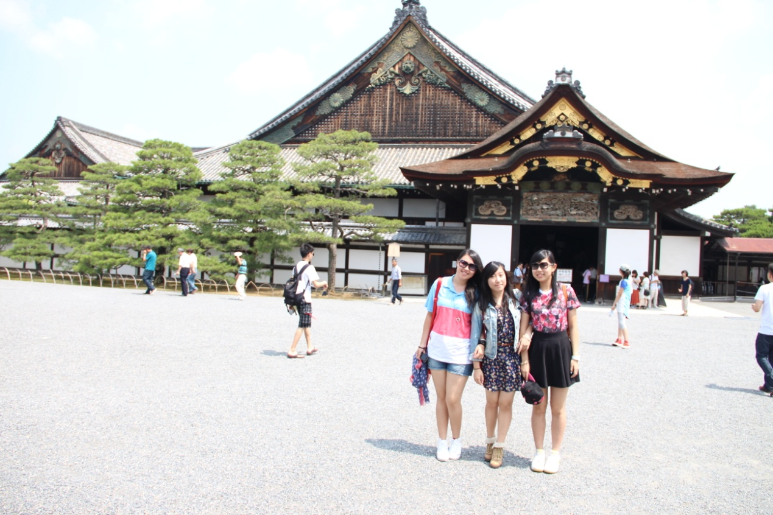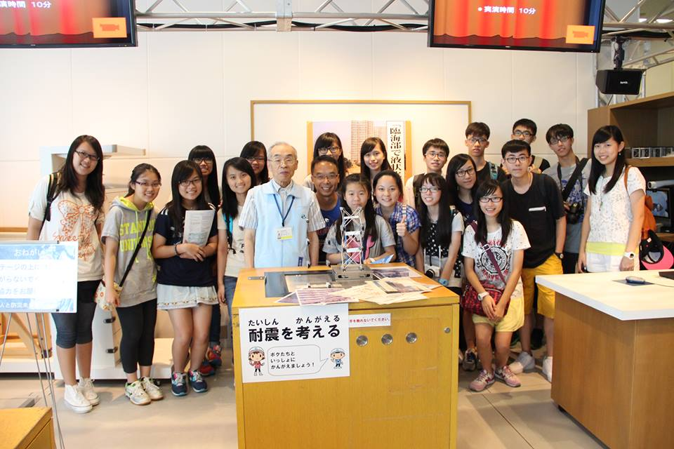

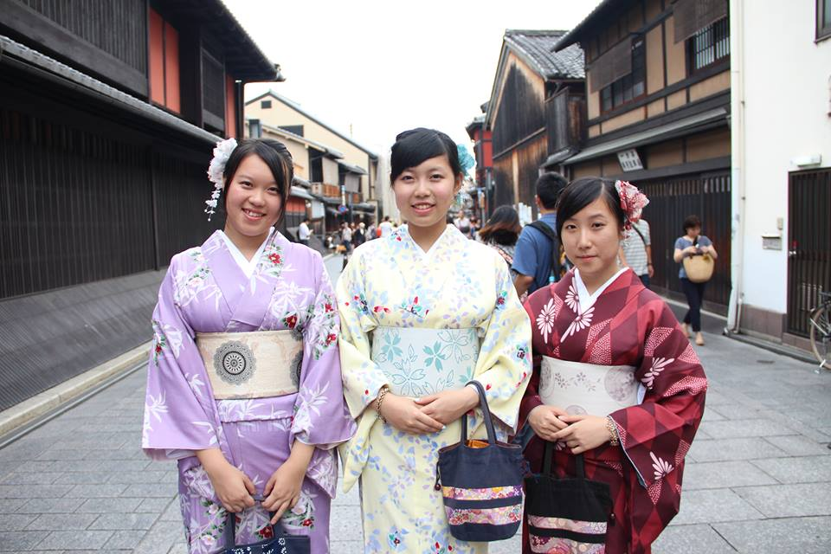

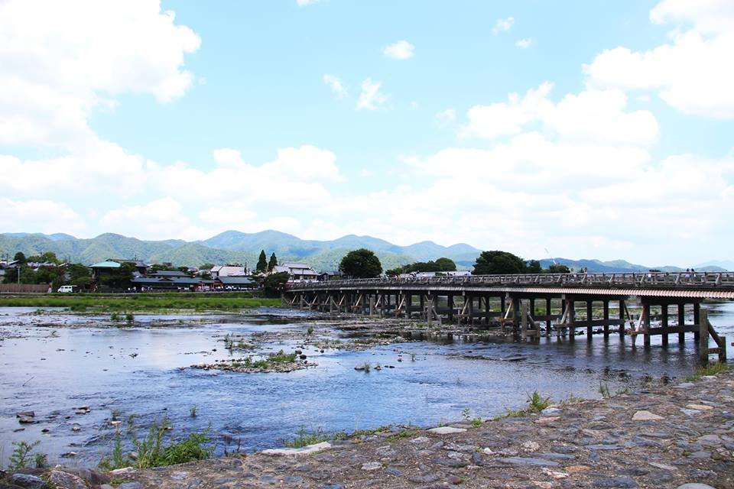

Yuki Cheng(6C), Elaine Shum(6E)